

State of Michigan-Lead and Copper Rule Lead Service Line Replacements
What are the specific changes to the lead and copper rule?
- Lead sampling in homes with lead service lines now involve a first liter water sample and a new fifth liter water sample to represent water that has been contained in the lead service line (Compliant).
- Preliminary service line inventories are due to EGLE by January 1, 2020 (Completed).
- By January 1, 2021, communities that have lead service lines must begin replacing them (In-Process).
- Water supplies are required to replace an average of 5 percent of their lead service lines every year for the next 20 years (2041 deadline) unless an alternate schedule is approved by EGLE (In-Process-Compliant).
- Water supplies are now responsible for removing the entire lead service line from the main to the home including all costs. Partial lead service line replacements are now banned.
- Complete service line inventories are due to EGLE by January 1, 2025 (In-Process-Hydro-Excavating via EGLE three-of four-point inspection method (Meter location and both sides of the curb box-not at main).
- The Action Level for lead in drinking water will be lowered from the current level of 15 parts per billion (ppb) to 12 ppb on January 1, 2025.
We’re Replacing Lead Service Lines
Why? What?

The Michigan Lead and Copper Rule states that all lead service lines need to be replaced within the next 20 years (2041 deadline).

Through our lead service line program, we’re replacing lead service lines in targeted areas based on the status of the comprehensive Distribution System Materials Inventory (DSMI) assessment based on available funding for targeted areas, water main project areas, and certain street projects.





Where?

PRIVATE

PUBLIC

Property Line

Water Meter

Curb Box Water Main

Water Service Line

What is the lead service line replacement program?

The city is replacing lead service lines at no cost to property owners that meet certain requirements:

- There is a water service leak on the lead water service line (private or public). The city will have a contractor replace private lead water service lines. Negligent actions by a property owner or contractor may disqualify the service from city sponsored replacement, requiring the property owner or their contractor to cover the replacement. This includes any activity by the property owner or property owner’s contractor that disturbs a lead service line causing it to leak.

Private lead service line replacements require the property owner sign a “Water Service Line Agreement” before work can begin on the property. Failure to execute an agreement will delay replacement or could lead to water service being discontinued. Property owners may also have their own contractor replace a lead service line that is leaking at their own cost with a permit.

The Department of Public Works or a contractor will replace public lead water service lines. Due to contractor availability and supply chain issues, the city may provide temporary water service via a neighboring property. Neighboring property owners receive a water credit for the temporary usage.

- Your property is within a targeted replacement service line area, water main replacement project area, or certain street construction project area. All private and public lead service lines will be replaced.

- Your property is in a designated lead service line replacement area.

In accordance with the State of Michigan Lead and Copper Rule, the City of East Grand Rapids will be replacing all lead water service lines over the next twenty years (2021-2041).

Voluntary Lead Service Line Replacements

- If a property owner does not meet any of the noted service line replacement criteria, but desires to have a private lead service line replaced in advance of construction or targeted areas, they may do so at their own cost by hiring a licensed contractor with a permit. If a private lead service line is voluntarily replaced and the public service line is also lead, the city will coordinate to replace the public portion at no cost as partial lead service line replacements are no longer permissible.

- If a property owner does not have a private lead service line and the public service line is lead and voluntarily elect to replace the public lead service line outside of the lead service replacement line program strategy which includes a water main replacement project area or certain street construction area, they may do so at their own cost by hiring a licensed contractor with a permit.

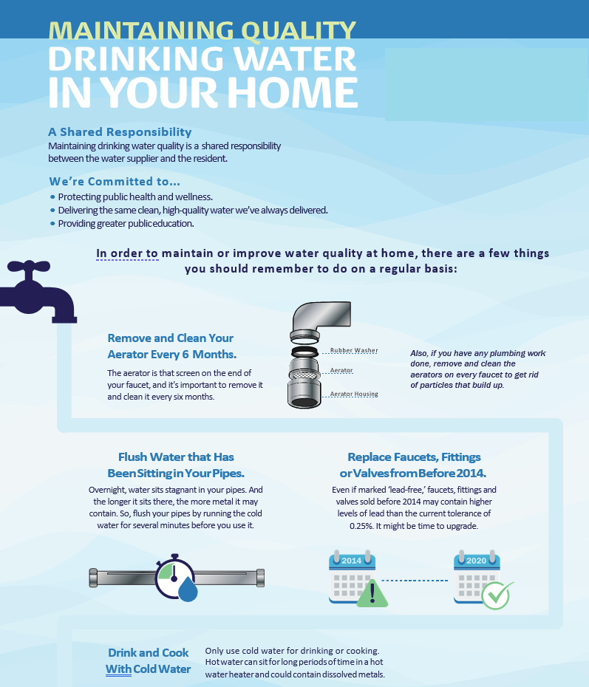

Temporary Use Agreement

Property Address:
Owner/Occupant(s):

THE OWNER/OCCUPANT(S) UNDERSTANDS AND AGREES AS FOLLOWS:
- I/We, the undersigned Owner/Occupant(s), grant permission to the City of East Grand Rapids, their representatives or contractors, (collectively referred to “the City”) to enter upon the premises identified above to replace the existing private portion of the water service line which extends from the curb stop to the water meter located within the premises (hereinafter referred to as the “project”).
- In order to complete the project described in paragraph 1, I/we agree to allow the City access to the existing water supply system, the existing driveway, lawn areas, and basement or meter area, as needed until the work is complete.
- Upon completion of the project, the City shall restore the premises as follows:
  - All established lawn area that is damaged as a result of the project will be repaired with topsoil and seed.
  - Any portion of the existing driveway damaged as a result of the project will be repaired and restored with like materials and to matching thickness.
  - Trees or other landscaping, if any, will be preserved and protected during the project. Any trees or landscaping damaged due to the project will be restored with standard nursery stock of like or similar species.
- I/We understand and acknowledge by signing this agreement that replacement of the private water service line, as identified in paragraph 1, does not constitute any further responsibility of this private water service line by the City. However, the City will guarantee the private water service line for ONE year after construction. The private service line and interior plumbing and sewer lateral remains the private property of the Owner and continues to be the full responsibility of the Owner at all times now and in the future.

Owner (s) – Signature (s)

Owner (s)– Print Name (s)

**Owner Phone #: _______________ and e-mail address: __________________ for contractor scheduling**

Director of Public Works – Signature (or Designee)

Print Name

**Must be returned to the City in advance of work being completed. Agreement must be filed in the associated property file**

Service Line and Internal Plumbing Flushing Instructions
DEAR WATER CUSTOMER:
The City of East Grand Rapids would like to inform you that we recently performed routine work on the water system and your water service line may need flushing. We recommend that you flush your interior plumbing to remove any particles that may have broken loose inside your pipes.

Please follow the instructions below to maintain the quality of the water in your home:
- Open the outdoor water faucet closest to the service line that enters your home. Allow it to run for approximately 10 minutes. Next, repeat this same process on all faucets inside your home using the cold tap only. Begin with the faucets at the lowest level of the home. Be sure to remove the faucet aerators on interior faucets (a small screen that is screwed into the faucet) before turning on the water.
- If there is no outside faucet, begin at the interior faucet closest to your water meter after removing the aerator.
- Continue with the cold-water faucets at the lowest level of your home after removing aerators and systematically fully open the faucets throughout your home.
- Allow the cold water to run for at least 10 minutes from each faucet. Don’t forget to include your bathtubs and showers.
- Turn off each faucet beginning with those located at the highest level of your home.
- Clean and reinstall all faucet aerators.

During this process:
  - Avoid consuming the water. This flushing process is meant to stir up sediment in your pipes to rinse it out. After this process is completed, you may use your water as usual.
  - Do not use hot water or open hot water faucets.
  - Do not use an ice maker or a filtered water dispenser.

Thank you for your cooperation.

East Grand Rapids Department of Public Works

If you have any questions, please contact us at 616-940-4817 (Engineering) or 616-940-4870 (Operations)

F:\CITYSERVICES\Water\Lead Information\Water Service Line-Public-Private Replacement Policy-With Agreement-Information

