NOTICE-Lead Water Service Line Replacements-Public

January 2025

Dear East Grand Rapids Resident/Property Owner:

A contractor working with the East Grand Rapids Department of Public Works will be replacing identified public side lead water service lines that were visually confirmed from a water service line survey.

Summary:

- You have a public water lead service line serving your property. The city is replacing this line at no cost to you.
- You do not have to do anything in advance of this work as it will be completed in the public right of way, from the water main to the shut off-see graphic below.
- Please read the information provided and follow instructions and recommendations.

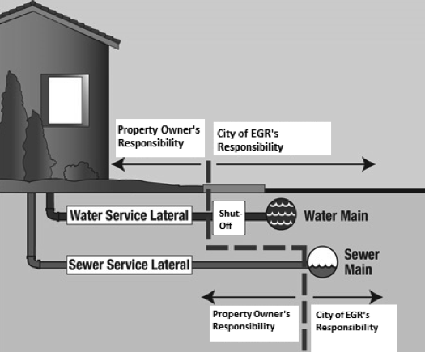

Details:

Project Information:

- Lead Service line replacement areas are targeted based on near future road or utility construction projects in accordance with an asset management strategy.
- Timeline is anticipated from January to June.
- Construction may take place between the hours of 7:00 AM and 9:00 PM Monday through Saturday per City Ordinance, although it is anticipated most work will be completed between 7:00 AM and 3:00-5:00 PM each day, Monday-Friday.
- Construction progress may be impacted by weather, availability of materials, scheduling conflicts and/or unforeseen emergencies. Patience and understanding are appreciated.
- The contractor is anticipated to complete 2-3 services per day.
- In addition to this notice, a notice will be provided within 24 hours of each scheduled lead service line replacement for properties that have a lead water service line with any additional instructions when contractors are in your specific area. The contractors will be working on removing lead service lines from December to June. To monitor closer timeframes please check the Construction Updates page as noted at the end of this notice.
- There is no cost for water service line replacements.
- Restorations will be completed as soon as possible in accordance with weather conditions. Temporary restorations will be made during winter months in some instances with complete restorations completed in the spring.
- Contractors are bonded, licensed, insured under contract with the city.

Traffic Impacts:

- Traffic will be maintained to local traffic, so residents who live in the area can gain ingress and egress access to their respective homes/property. Residents should exercise caution in active works zones.

Contractors: Groundhawg Excavating of Lowell, MI.

Other Information:

- Existing on-street parking may be limited, depending on the locations of the access pits or equipment. Temporary “no parking” signs will be placed in advance of any parking restrictions and locations.
- The city requests that residents identify irrigation system sprinkler heads/lines that may be in the City right-of -way with stakes or flags labeled “irrigation” in advance of the project. This will help eliminate damage to any systems.
- Additional information is available related to lead and drinking water at www.eastgr.org the selecting the “Government” tab at the top of the page, followed by “Public Works” and “Water/Sewer Systems” tab, including a water service line materials inventory map or via the QR Code below as well as testing results, water quality reports, and additional information related to protective measures residents can take.

The city appreciates patience and understanding as important infrastructure is replaced and rehabilitated that will serve the community for the future.

Questions may be directed to the city by calling the Department of Public Works Administrative/Engineering Office at 616-940-4817 or Operations Office at 616-940-4870.
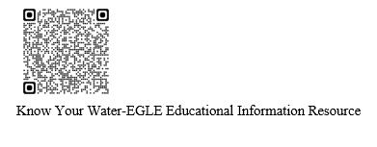
Respectfully,
East Grand Rapids Department of Public Works



Construction Updates Information page QR Code

Water Service Material Inventory Map

